# Web Programming Assignment Design – SOSA Product Management System

My system allows the admin to add/delete clothes and accessories and update their details (brands, categories, quantity etc.).

Also allows the admin to view and search clothes and accessories, sort the products in ascending and descending order and updates it all in real time.

[http://http://student30291.bucomputing.uk/console/](http://http:/student30291.bucomputing.uk/console/)

# Entity Relationship Diagram

**List of Entities**

There are three entities used in this system. They are:

* Brands
* Categories
* Products

Figures below show the relationship between each entity:

Products – Brands

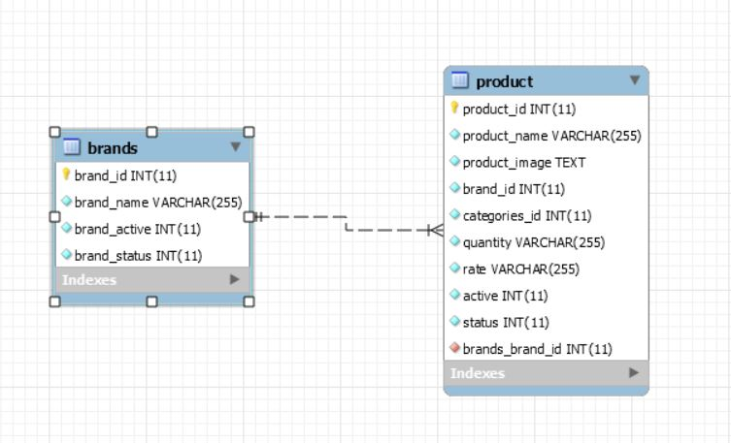

* Product has one brand
* One brand has multiple products

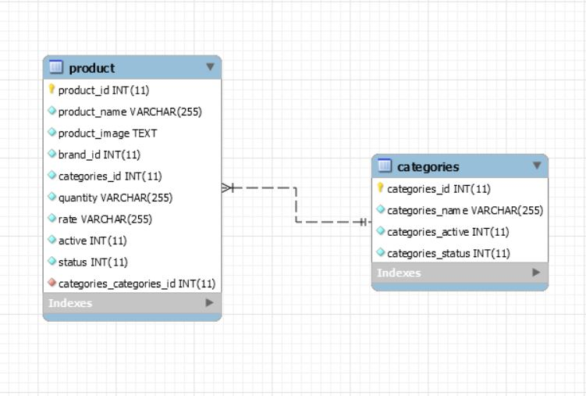Product – Categories

* Product has one category
* Category has more than one product

**ER Diagram**

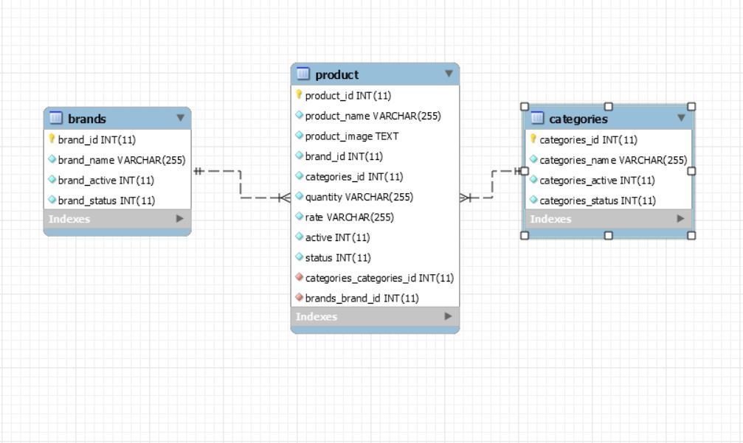

The ‘product’ table will act as a link table for ‘brands’ and ‘categories’. This is because brands and categories can both have more than one product.

I chose to create 3 tables for this project because it eliminates the admin with making user errors by naming the brands and the categories differently every time.

‘Product’ Table

In this entity, there are 9 attributes which are:

* product_id
* product_name
* product_image
* brand_id
* categories_id
* product_quantity
* product_rate (Price)
* product_active
* 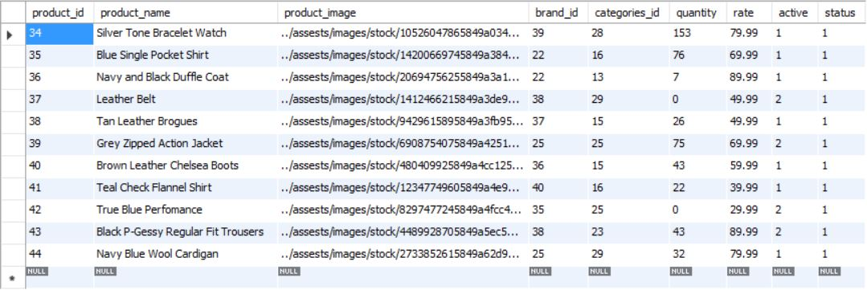status

There is one primary key and two foreign keys in this entity. The primary key is the Product ID and the two foreign keys are Categories ID and Brand ID. The reason why there are two foreign keys is because the Product table is a link table between the Brands and Categories table. Product Status indicates to the user whether the product is available for the customers to purchase.

‘Brands’ Table

In this table, there are 4 attributes which are:

* brand_id
* brand_name
* brand_active
* 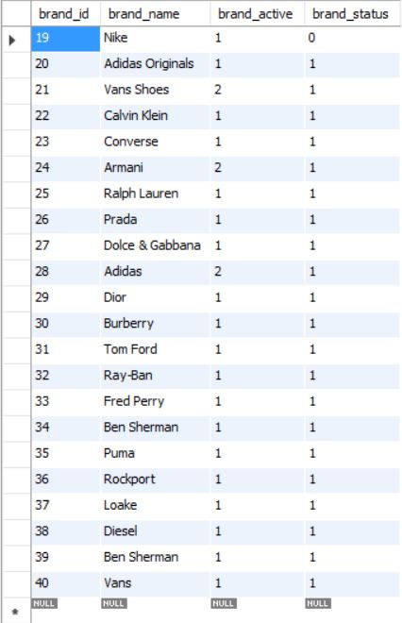brand_status

There is only one primary key in this entity, no foreign keys; the primary key is Brand ID. Brand Active tells the admin whether the brand is available for customers to purchase. Brand Status is used to make sure the Brand has successfully been added to the table on the site.

‘Categories’ Table

In this table, there are 4 attributes, just like on the ‘Brands’ table. They are:

* categories_id
* categories_name
* categories_active
* 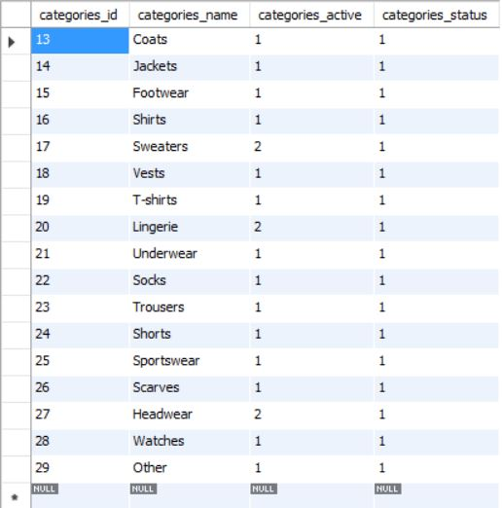categories_status

The functions of each attribute in this entity are very similar to the Brands table; the primary key is Categories ID.

# PHP

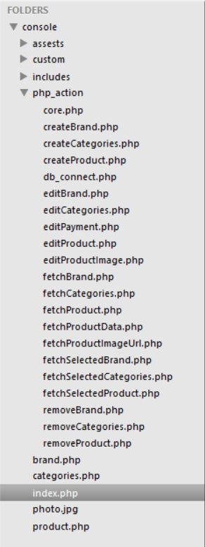

I separated out the actions into their own PHP file so it makes the development much simpler. The ‘db_connect.php’ file makes sure that the user has connected to the database containing the three tables.

The ‘core.php’ file contains a ‘start_session’. This function returns TRUE if a session was successfully started, otherwise FALSE. The rest of the PHP files contain ‘require_once’ for the ‘core.php’ file.

There is a PHP file for each webpage, (‘index.php’, ‘products.php’, ‘categories.php’ and ‘brand.php’). Each of them contains a ‘require_once’ function for the header and the footer to make sure that they are on the pages.

# Test Cases

